**GARAGE MANAGEMENT SYSTEM**

**College Name: Shri Nehru Maha Vidyalaya college of arts and science**

**College Code:** **Bru26**

**TEAM ID: NM2025TMID28649**

**TEAM MEMBERS:**  4

**Team LeaderName: V RAGUL**

**Email:** **ragulv2512@gmail.com**

**Team Member1: SANTHA KUMAR S**

**Email: santhakumar93083@gmail.com**

**Team Member: JANARTHAN S**

**Email: sivakumarjanarathan06@gmail.com**

**Team Member: MALAI MANNAN S**

**Email: 23bcamalaimannan@gmail.com**

# 1.INTRODUCTION

## 1.1 Project

The Garage Management System is a valuable tool for automotive repair facilities, helping them deliver top-notch service, increase operational efficiency, and build lasting customer relationships. With its user-friendly interface and powerful features, GMS empowers garages to thrive in a competitive market while ensuring a seamless and satisfying experience for both customers and staff

## 1.2 Purpose

The Garage Management System is a valuable tool for automotive repair facilities, helping them deliver top-notch service, increase operational efficiency, and build lasting customer relationships. With its user-friendly interface and powerful features, GMS empowers garages to thrive in a competitive market while ensuring a seamless and satisfying experience for both customers and staff

# DEVELOPMENT PHASE

**Creating Developer Account:**

By using this URL[**- https://www.salesforce.com/form/developer-signup/?d=pb**](https://www.salesforce.com/form/developer-signup/?d=pb)

* Created objects: customer details, appointment, service record, billing and feedback

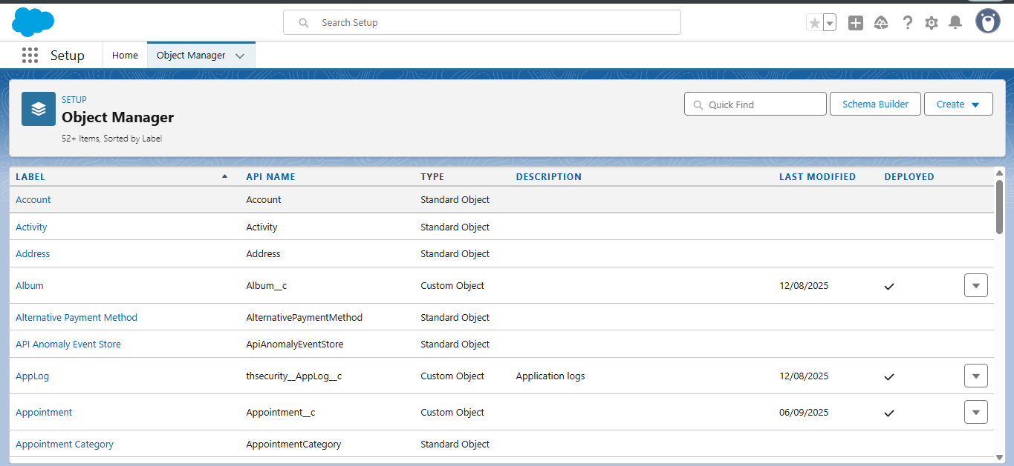

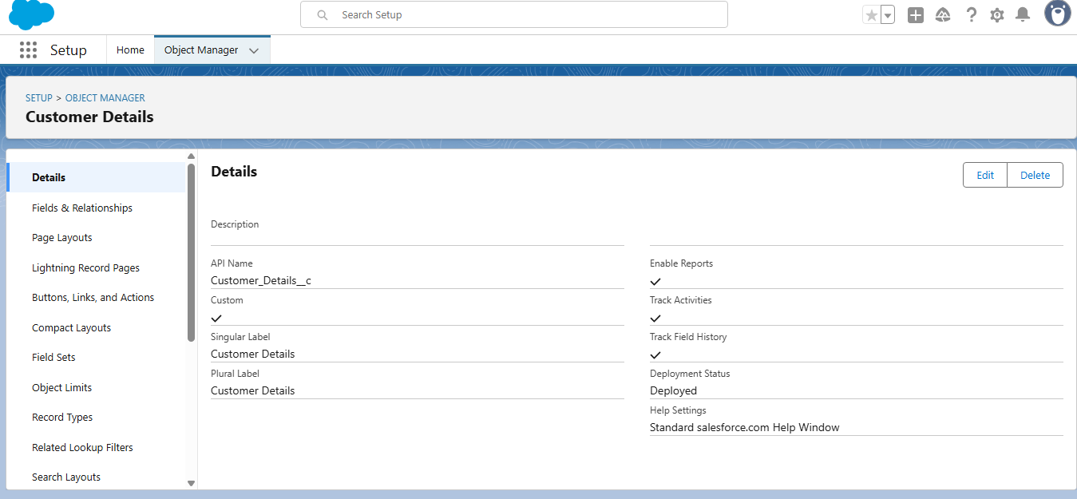

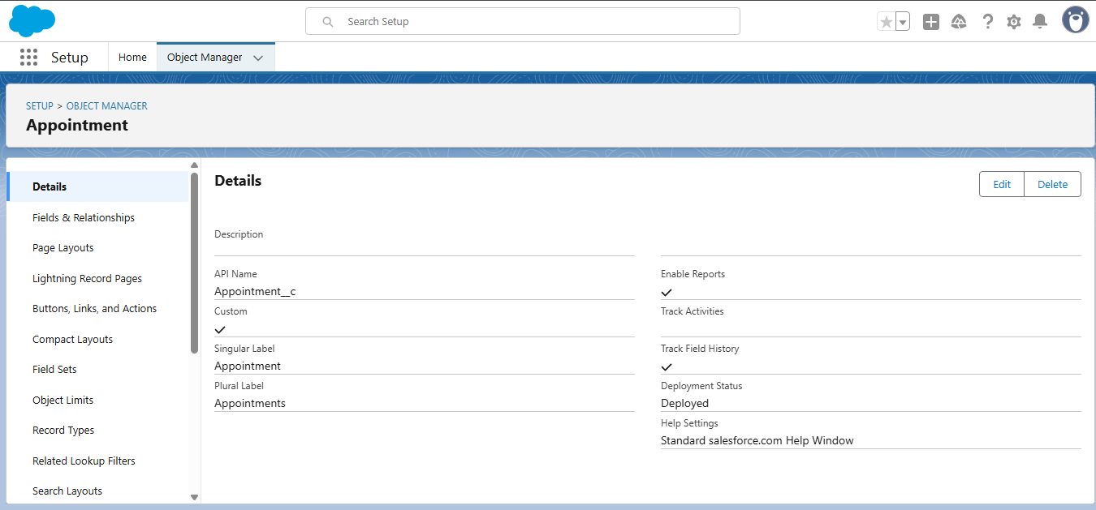

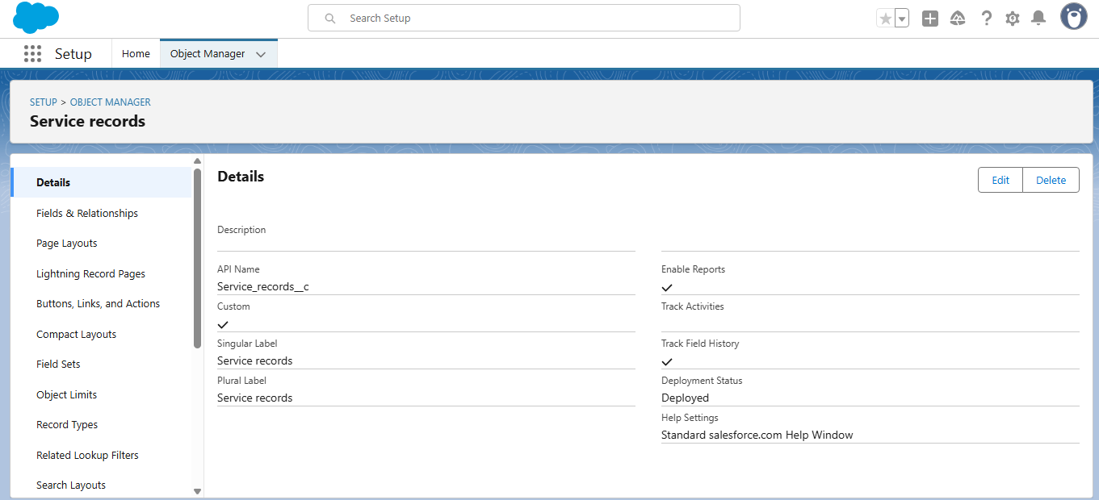

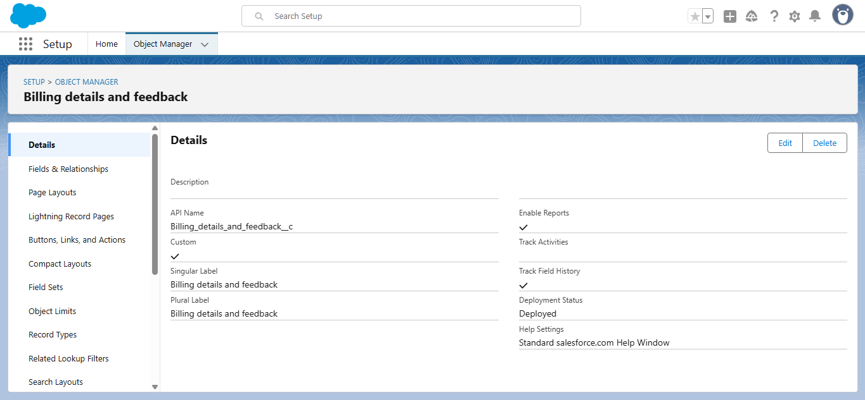

* Configured fields and relationships

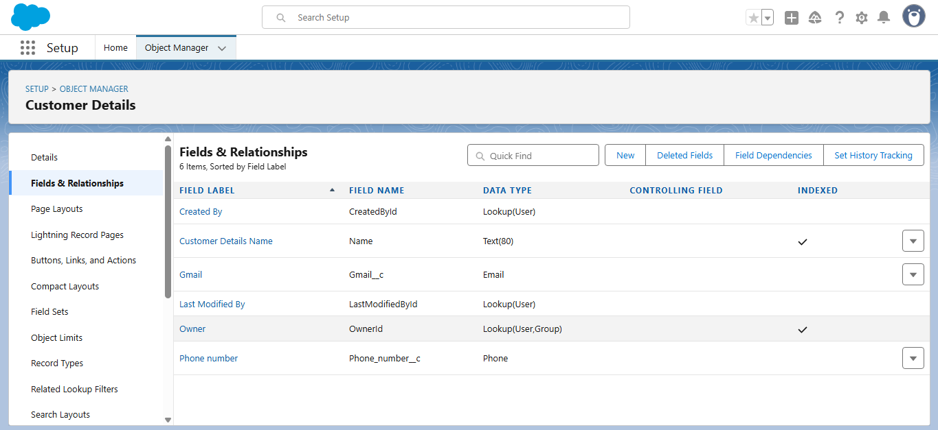

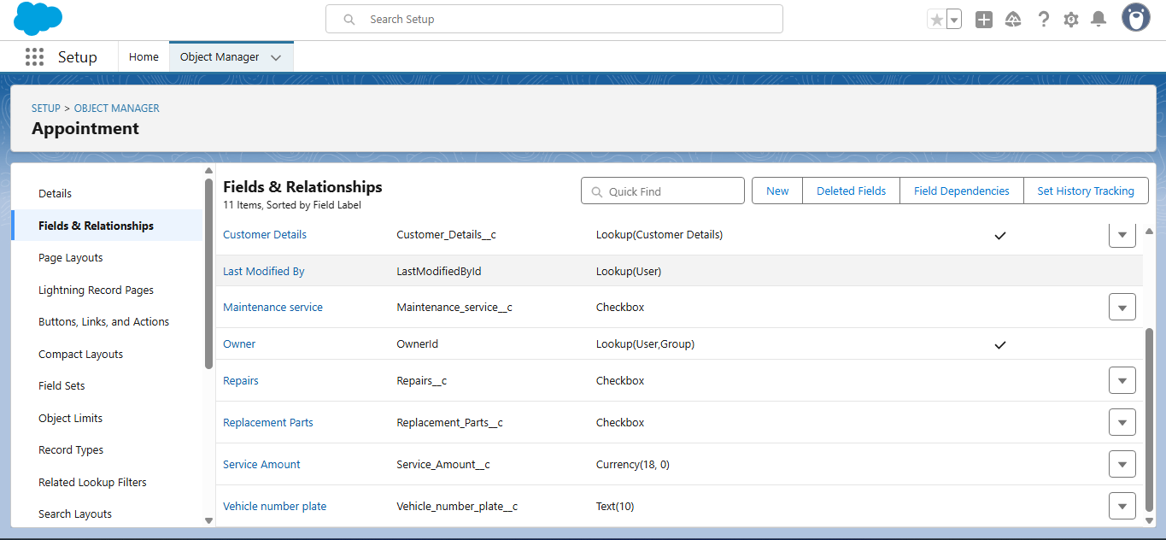

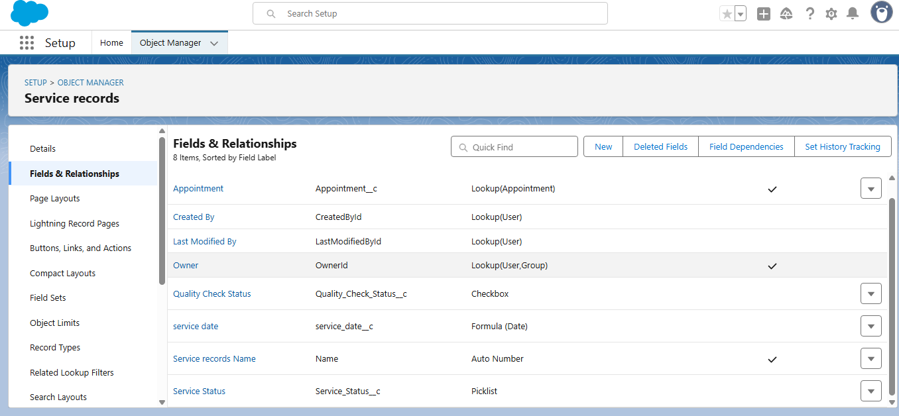

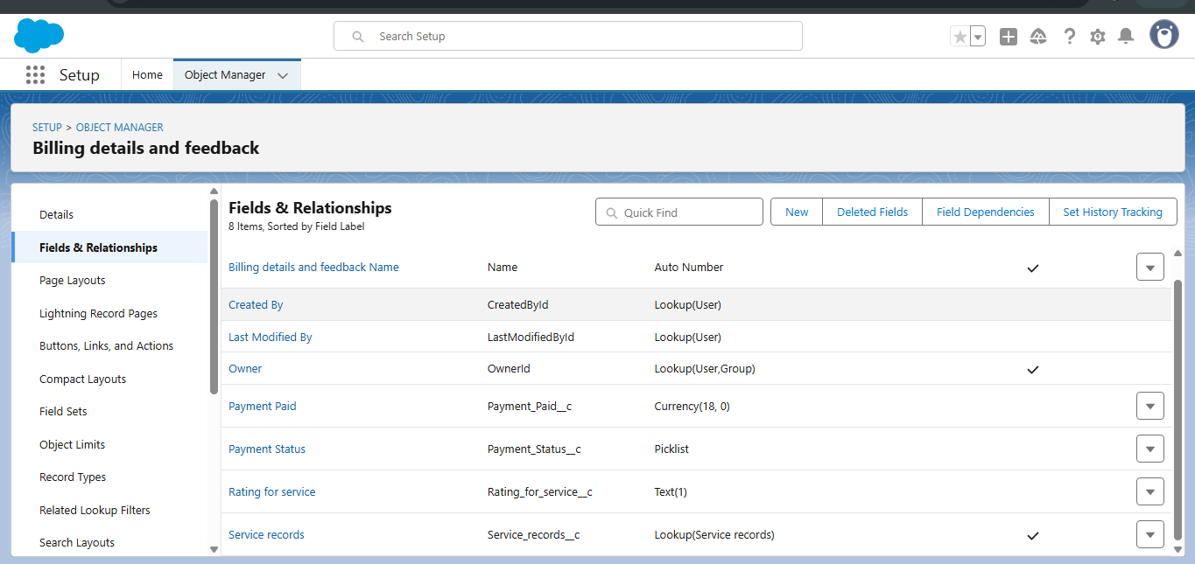

* CREATING TABS

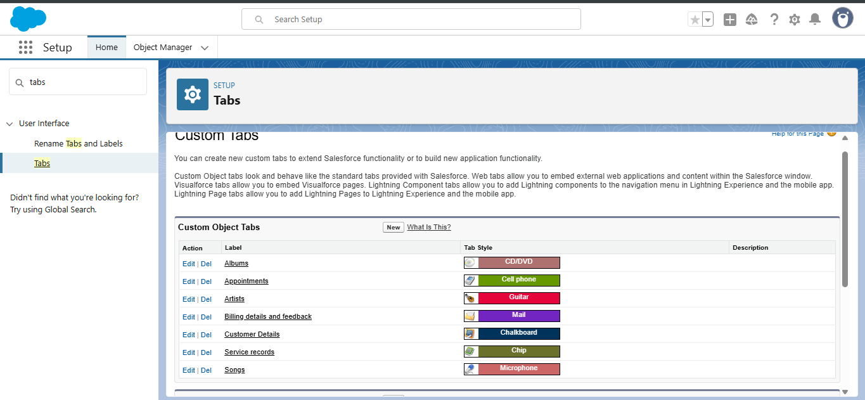

* Lightining app

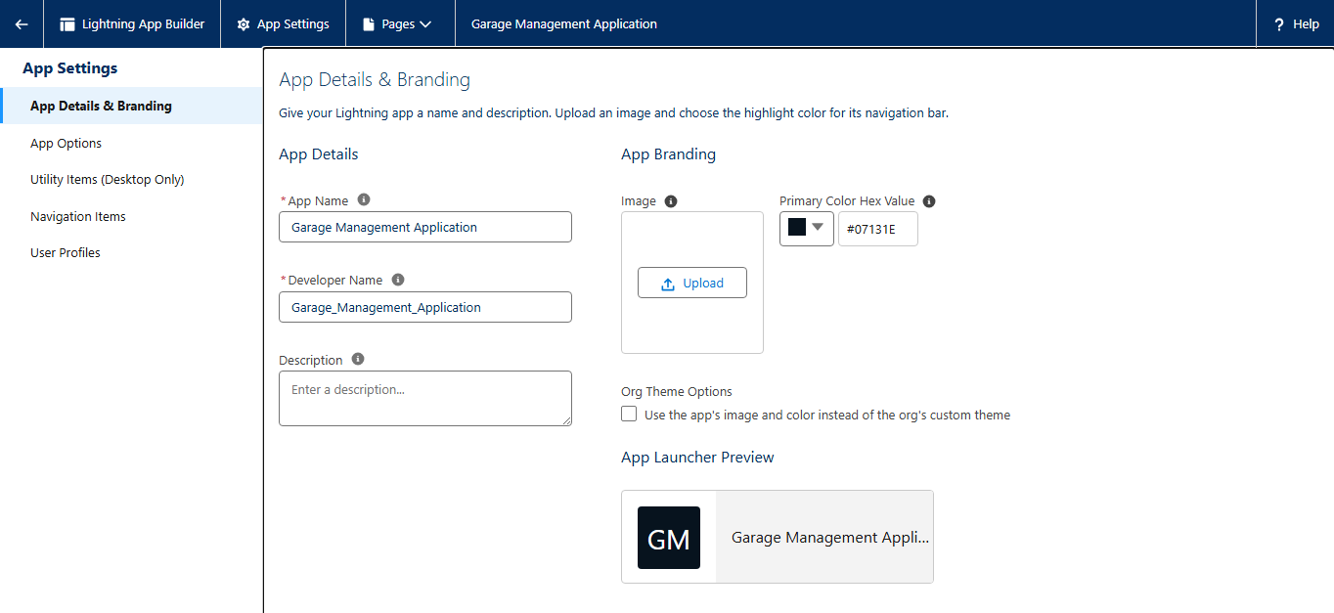

* Creating fields





* To create a validation rule

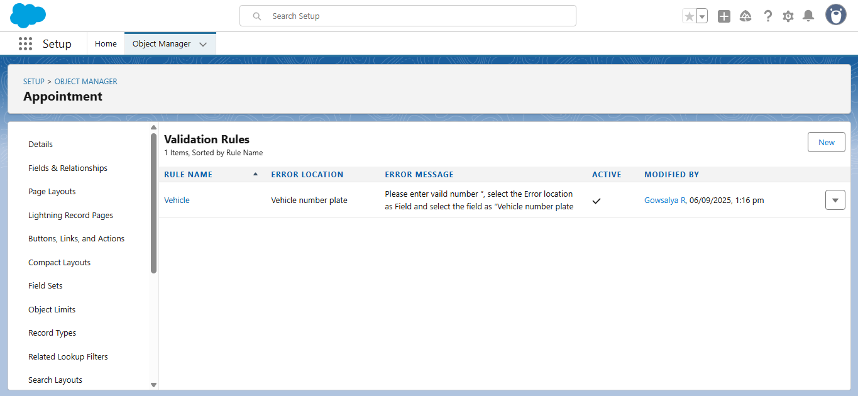

* Added Apex class for appointment distribution

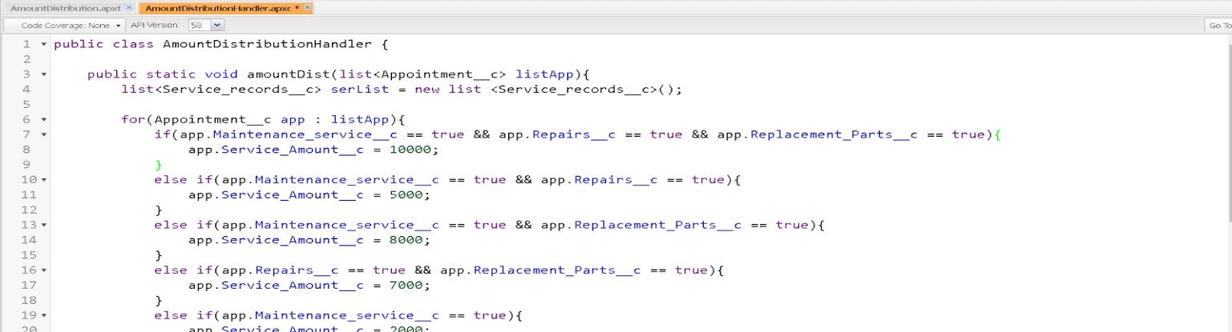

* Schedule appointment using Apex triggers

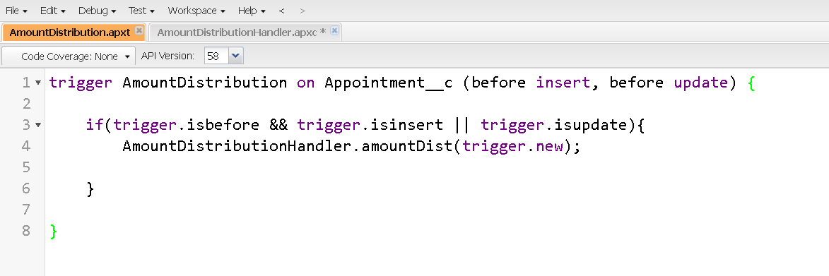

* Creating duplicate rule

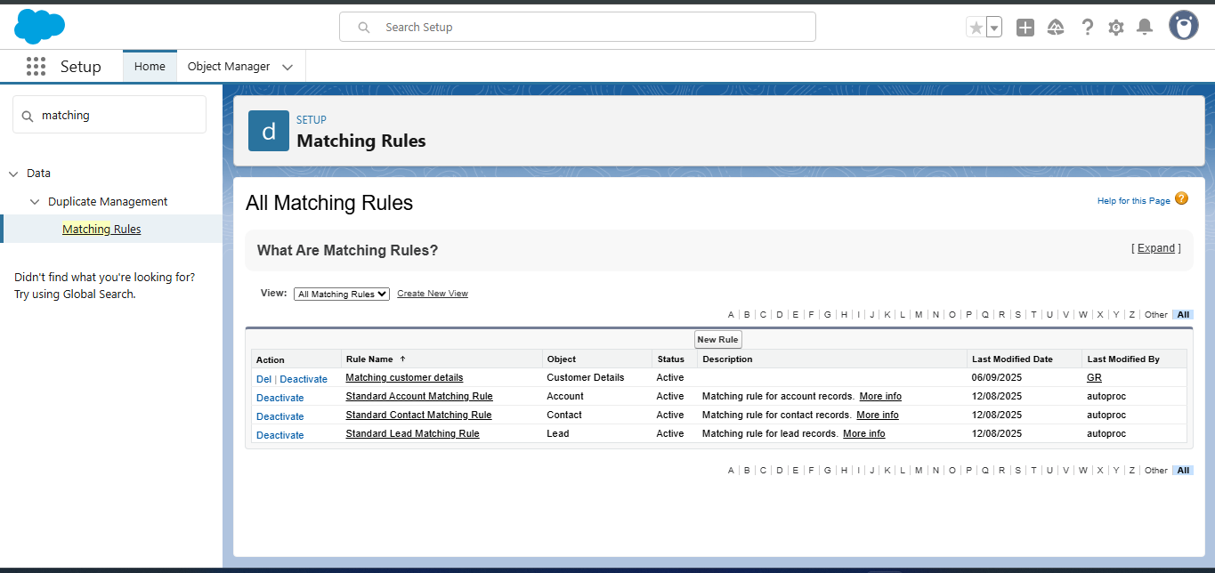

* Profile creating

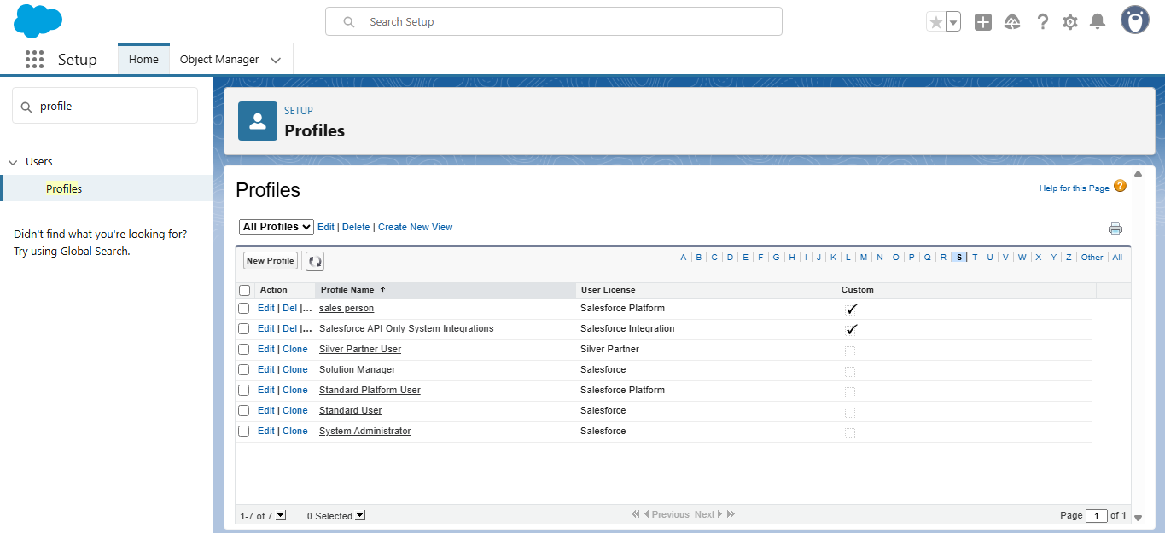

* Role

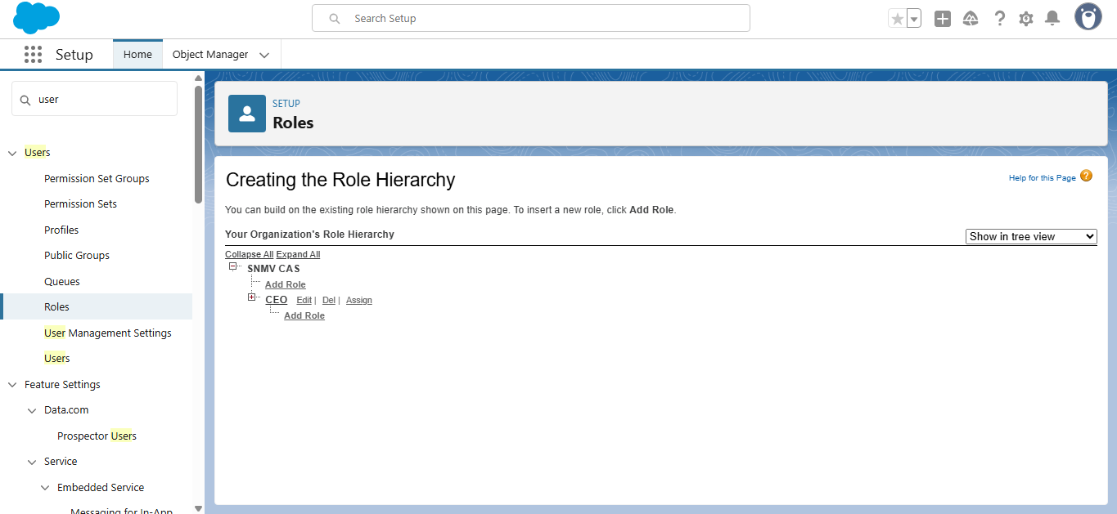

* Users

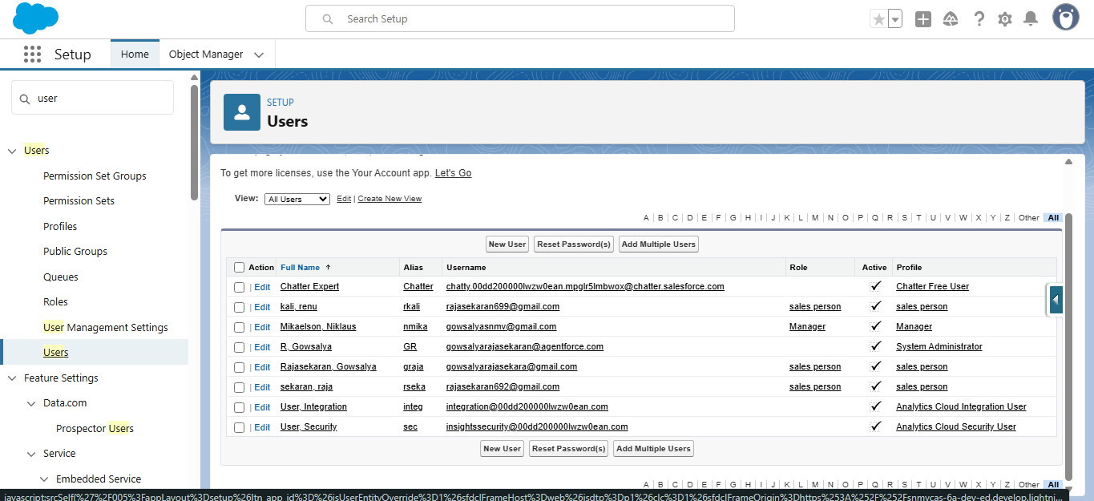

* Public group

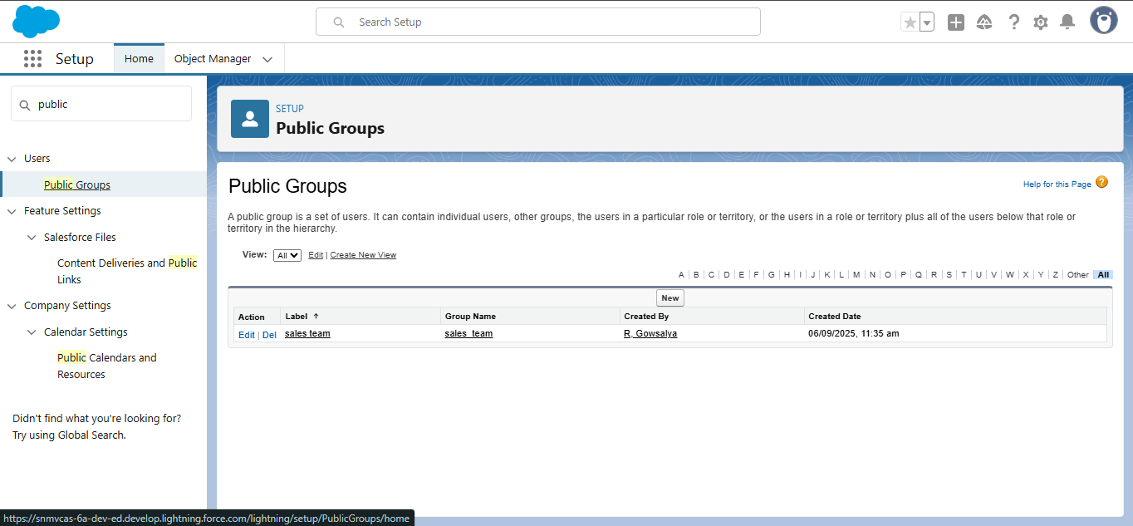

* Sharing setting

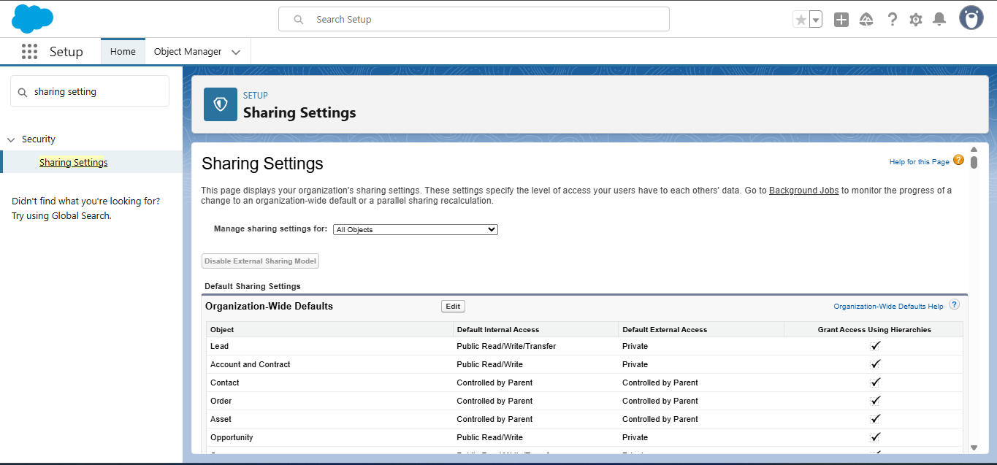

* Flows

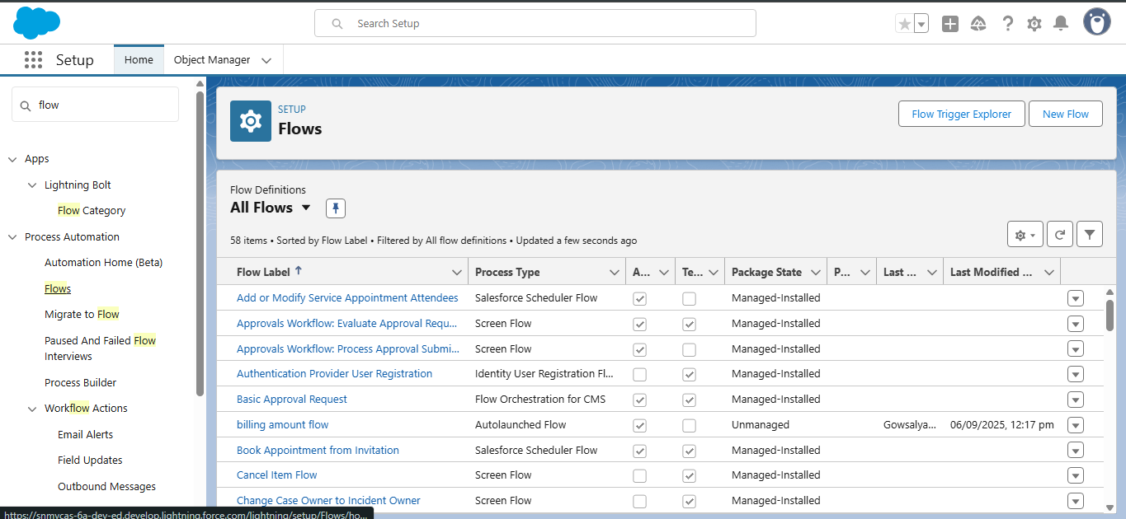

* Reports

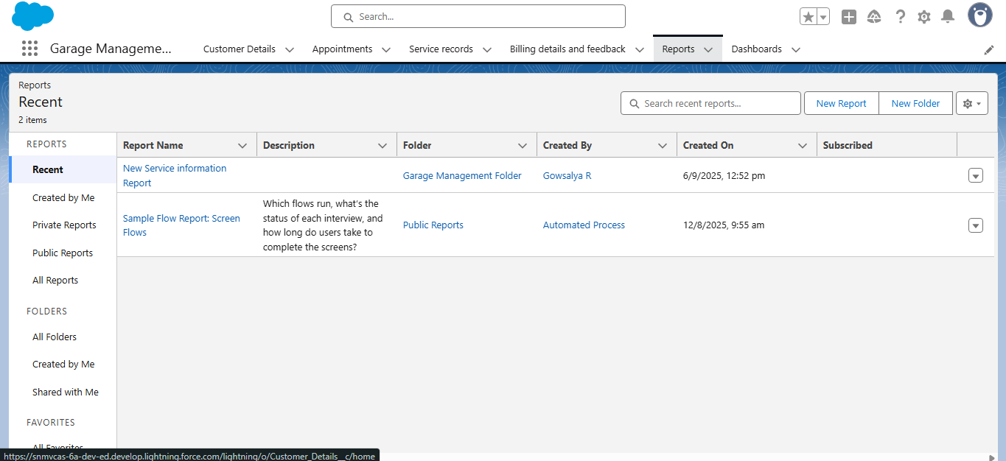

* Dashboard

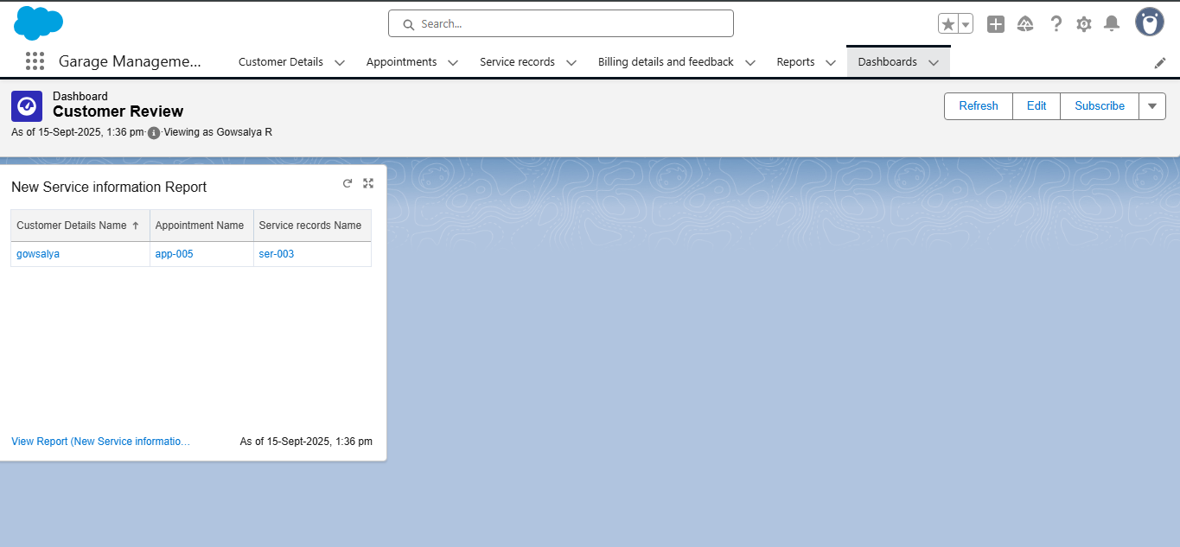

* Customer details

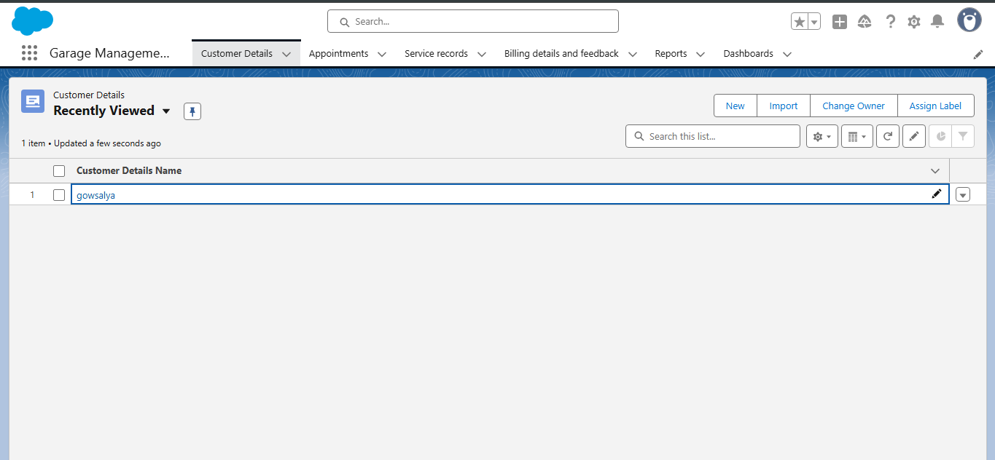

# CONCLUSION

The Garage Management System is a valuable tool for automotive repair facilities, helping them deliver top-notch service, increase operational efficiency, and build lasting customer relationships. With its user-friendly interface and powerful features, GMS empowers garages to thrive in a competitive market while ensuring a seamless and satisfying experience for both customers and staff.

## APPENDIX

● **Source Code:** Provided in Apex Classes and Triggers

public class AmountDistributionHandler {

    public static void amountDist(list<Appointment__c> listApp){

        list<Service_records__c> serList = new list <Service_records__c>();

        for(Appointment__c app : listApp){

            if(app.Maintenance_service__c == true && app.Repairs__c == true && app.Replacement_Parts__c == true){

                app.Service_Amount__c = 10000;

            }

            else if(app.Maintenance_service__c == true && app.Repairs__c == true){

                app.Service_Amount__c = 5000;

            }

            else if(app.Maintenance_service__c == true && app.Replacement_Parts__c == true){

                app.Service_Amount__c = 8000;

            }

            else if(app.Repairs__c == true && app.Replacement_Parts__c == true){

                app.Service_Amount__c = 7000;

            }

            else if(app.Maintenance_service__c == true){

                app.Service_Amount__c = 2000;

            }

            else if(app.Repairs__c == true){

                app.Service_Amount__c = 3000;

            }

            else if(app.Replacement_Parts__c == true){

                app.Service_Amount__c = 5000;

            }

    }

    }

}

trigger AmountDistribution on Appointment__c (before insert, before update) {

    if(trigger.isbefore && trigger.isinsert || trigger.isupdate){

        AmountDistributionHandler.amountDist(trigger.new);

    }

}